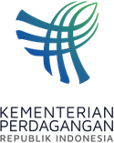
PRESS RELEASE
Public Relations Bureau
Bldg. I Fl. 2, Jl. M.I. Ridwan Rais No. 5, Jakarta 10110 Phone: 021-3860371/Fax: 021-3508711
www.kemendag.go.id

12th ASEAN-Canada Consultation Meeting,
Minister of Trade Zulkifli Hasan: Target ACFTA to be Completed in 2025
Semarang, 20 Agustus 2023 – The 12th ASEAN Economic Ministers (AEM)-Canada Consultation Meeting ratified a new target for completing the ASEAN-Canada Free Trade Agreement (ACAFTA) negotiations in 2025.

This was conveyed by the Minister of Trade, Zulkifli Hasan, after chairing the 12th AEM-Canada Consultation Meeting on Sunday (20/8) in Semarang, Central Java. At the meeting, the Canadian delegation was led by Canada's Minister of Export Promotion, International Trade and Economic Development, Mary Ng. This meeting is part of the series of the 55th AEM Meeting and related meetings held on 17-22 August 2023.

"Today's 6th meeting is the 12th consultation of ASEAN economic ministers with Canada. This meeting succeeded in ratifying a new target, namely the completion of the ACAFTA negotiations in 2025 and directives for the negotiations to be intensified," said Trade Minister Zulkifli Hasan.

Trade Minister Zulkifli Hasan explained that the AEM and Canada consultation meeting discussed economic recovery, particularly strengthening supply chains; digital economy; food security; and sustainable development. The AEM-Canada Consultation Meeting was preceded by AEM consultations with the Canada-ASEAN Business Council (CABC). The meeting discussed the implementation of CABC cooperation projects and recommendations for 2023.

The ratification of ACAFTA's new targets was a proposal from the Trade Negotiation Committee (TNC). Until now TNC has held five meetings consisting of four regular meetings and one special meeting. The next TNC meeting is planned to be physically held on 25-29 September 2023 in Bali, Indonesia.
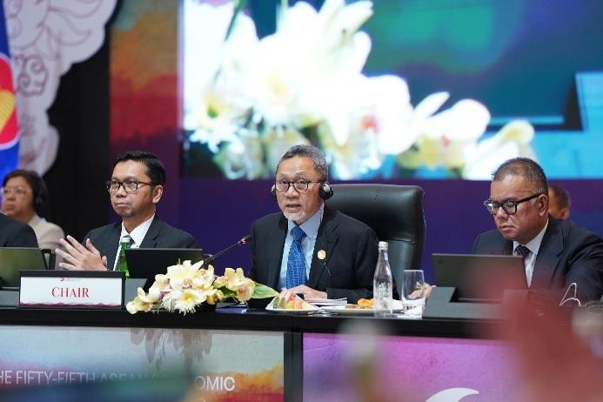
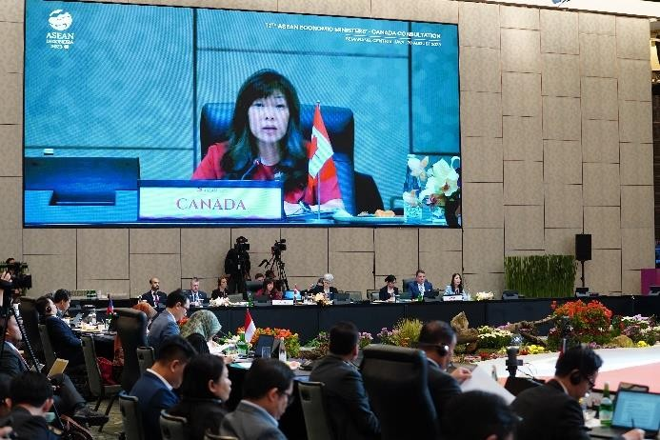

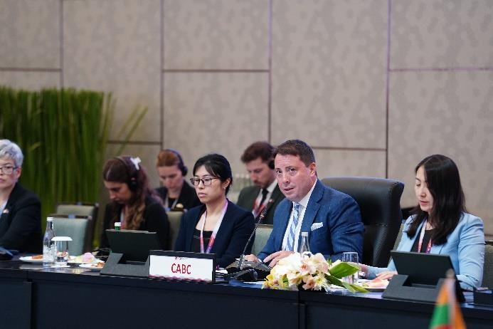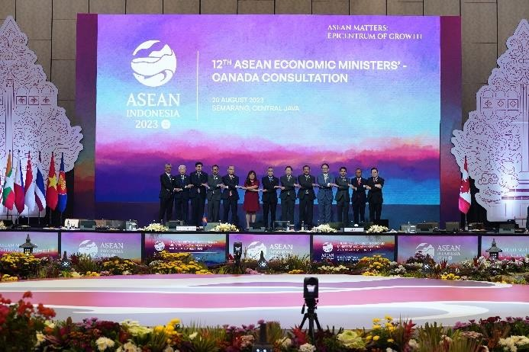

--end--

For further information please contact:  Ani Mulyati  Head of Public Relations Bureau Ministry of Trade  Email: pusathumas@kemendag.go.id | Dina Kurniasari  Director of ASEAN Negotiations  Directorate General of International Trade Negotiations Ministry of Trade  Email: dina.kurniasari@kemendag.go.id

